REPLICATION :- Process where data from site server copied to central server
1. Repliaction process start by calling unlstart.sh script on Site Server
30 03 * * 0-6 (cd /essn/aer/repl/script; ./unlstart.sh aer AER /essn/aer) >> /essn/aer/repl/log/unlstart.log 2>&1
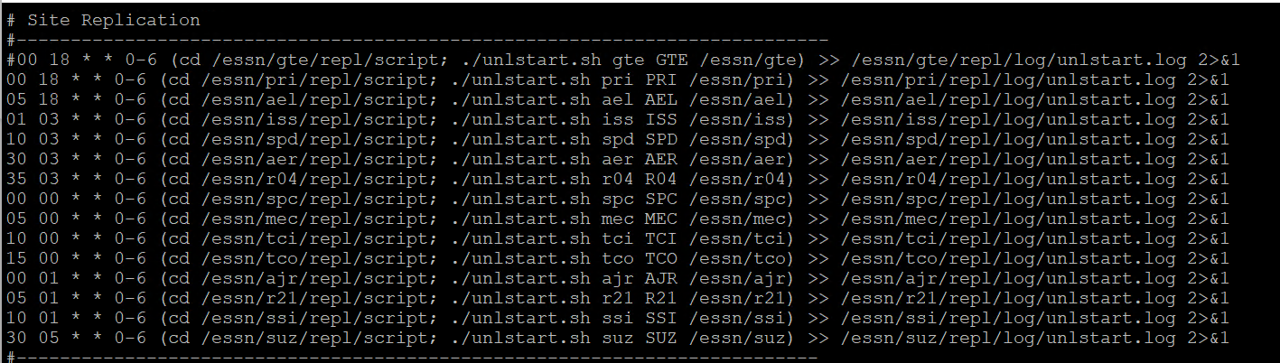

2. unlstart.sh script will call the unload.pl perl script
/usr/bin/perl $BASE/repl/script/unload.pl N $DB $SITE $BASE >> $BASE/repl/log/unload.log 2>&1

3. unload.pl will perform the following steps
BASE :- /essn/aer
DB aer
site :- AER

Set the variables
$PATH = '/essn/ros/repl' ;
$CPATH = '/essn/ros/repl' ;
$STAGE = '/stage' ;
$DATA = '/data' ;
$BACK = '/backup' ;
$LOGDIR = '/log' ;
$SOURCE = '/source' ;

$BIN = '/essn/ros/bin' ;
$SYSBIN = '/usr/bin' ;

$PERL = $SYSBIN.'/perl' ; OR /usr/bin/pearl;

$ZIP = $SYSBIN.'/gzip' ; OR /usr/bin/gzip
$UNZIP = $SYSBIN.'/gunzip' ; OR /usr/bin/gunzip

$LOG = $PATH.$LOGDIR ;
$CLOG = $CPATH.$LOGDIR ;

$QUAL = '_rep' ; # Transaction tbl name extention
$UNLOADSQL = 'unload' ; # SQL file name
$LOADSQL = 'load' ;
$DFILE = 'date' ;
$GO = 'goahead' ;
$OUTREPLPGM = 'outrepl' ;
---Central Server--
$ROSREPLPGM = 'rosrepl' ;
$ROSREPLOPPGM = 'rosreplop' ;

$ZIPEXT = '.gz' ;
$SQLEXT = '.sql' ;
$LOGEXT = '.log' ;

$GOAHEAD = $PATH.$DATA.'/'.$GO ; # goahed file
$PDATEDIR = $PATH.$DATA.'/' ; # Previous dates
$NDATEDIR = $PATH.$STAGE.'/' ; # New dates
$CDATEDIR = $CPATH.$STAGE.'/' ; # Central server date file

3a. List of tables which will be replicated
claim
claim_bulletin
claim_charges
claim_complaint
claim_cur_status
claim_deleted
claim_euro
claim_fail_code
claim_license_num
claim_link
claim_mfg_date
claim_non_reman
claim_operation
claim_promise
claim_scrap
claim_trouble
inventory
inventory_owed
pc_info
piece_part_shipment
piece_part_ship_detail
pre_exc_order
pre_exc_shipment
receipt_cust
receipt_cust_xfer
receipt_dealer
receipt_detail
receipt_detail_xfer
sdo_detail
shipment
shipment_detail
site_parameters
spec_proj_site_data
userid
userid_function_cde

Script will calls following subroutine in perl script to complete the replication process

3b. &load_tables - Load the _rep tables from the above mentioned table list
3c. &get_date - Get the date
3d. &backup_files - Move the previous run files from /essn/aer/repl/data to /essn/aer/repl/backup
3e. &create_sql - Create the sql script to load the data from _rep tables to files in /essn/aer/repl/script
3f. &unload_tables - Insert the data from _rep table to files in /essn/aer/repl/stage
3g. &move_data - Compress the files in /essn/aer/repl/stage directory. Move the file from /essn/aer/repl/stage to /essn/aer/repl/data

REPLICATION PROCESS ON CENTRAL SERVER
1. Start the replication process by running the shell script repl_daily.sh using the crontab
10 00 * * * /essn/rose/prod/repl/script/repl_daily.sh >> /essn/rose/prod/repl/log/repl_daily.log 2>&1
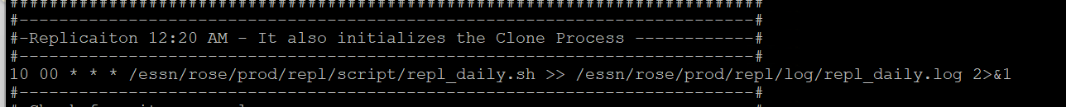

2. repl_daily.sh scripts calls replicate.pl for replication of data from sites to central server
/usr/bin/perl /essn/rose/prod/repl/script/replicate.pl ros /essn/rose/prod 4 >> /essn/rose/prod/repl/log/replicate.log 2>&1

3. Following processes will be complete as part of replicate.pl script

3a. Setup the variables

3b. Get the list of tables for which replication process runs
############### begin list
claim
claim_bulletin
claim_charges
claim_complaint
claim_cur_status
claim_deleted
claim_euro
claim_fail_code
claim_license_num
claim_link
claim_mfg_date
claim_non_reman
claim_operation
claim_promise
claim_scrap
claim_trouble
inventory
inventory_owed
pc_info
piece_part_shipment
piece_part_ship_detail
pre_exc_order
pre_exc_shipment
receipt_cust
receipt_cust_xfer
receipt_dealer
receipt_detail
receipt_detail_xfer
sdo_detail
shipment
shipment_detail
site_parameters
spec_proj_site_data
userid
userid_function_cde
############### end list

3c. Get the list of sites from where Central server will get the data
#GTE uskoaa05 015 030 /essn/gte
PRI uskoaa05 015 030 /essn/pri
#AEL uskoaa05 015 030 /essn/ael
AJR uskoaa05 080 060 /essn/ajr
R21 uskoaa05 070 060 /essn/r21
AER uskoaa05 215 005 /essn/aer
#R04 uskoaa05 218 004 /essn/r04
ISS uskoaa05 195 030 /essn/iss
MEC uskoaa05 045 060 /essn/mec
SPC uskoaa05 090 060 /essn/spc
SPD uskoaa05 195 030 /essn/spd
SSI uskoaa05 135 030 /essn/ssi
TCI uskoaa05 045 060 /essn/tci
TCO uskoaa05 045 060 /essn/tco
SUZ uskoaa05 015 030 /essn/suz

3d. Runs the subroutine &pull_data to get the files from each site to Central server /essn/rose/prod/repl/data directory

3e. Run the subroutine &process_data to process the data

3e.1. Process_data subroutine calls perl program load.pl $SITE $DB $BASE

3e.2. &get_date --Get the date information
3e.3. &uncompress_files --Unzip the files received from Site server /essn/rose/prod/repl/data to /essn/rose/prod/repl/stage
3e.4. &create_sql --Create the sql script to load the data from file in /essn/rose/prod/repl/stage directory to _rep tables
3e.5. &load_tables -- Load the data from file in /essn/rose/prod/repl/stage directory to _rep tables
3e.6. &update_tables -- Update the table claim_operation,sdo_detail,shipment tables
3e.7. &backup_files -- Backup the data from /essn/rose/prod/repl/stage to /essn/rose/prod/repl/backup directory
3e.8. &update_stats -- Update the site_stats table with last run information

3f. Run the $BASE/repl/script/replreport.sh /essn/rose/prod to verify the replreport.

